Supplementary Figures

Figure 1: conceptual of the niche model

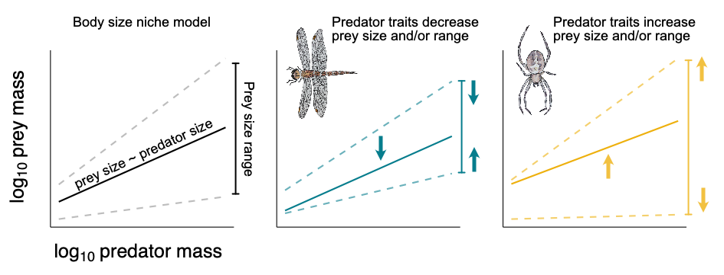

Predator traits can lower or raise the linear relationship between predator size and prey size. These traits may also increase or decrease the range of prey sizes available to a predator. These traits may include: gape limitation, tool use (e.g. webs or venom), hunting strategy, and locomotion, among others (e.g. Brose et al. 2019, Laigle et al.)

Table 1: Table: samples and sequencing run

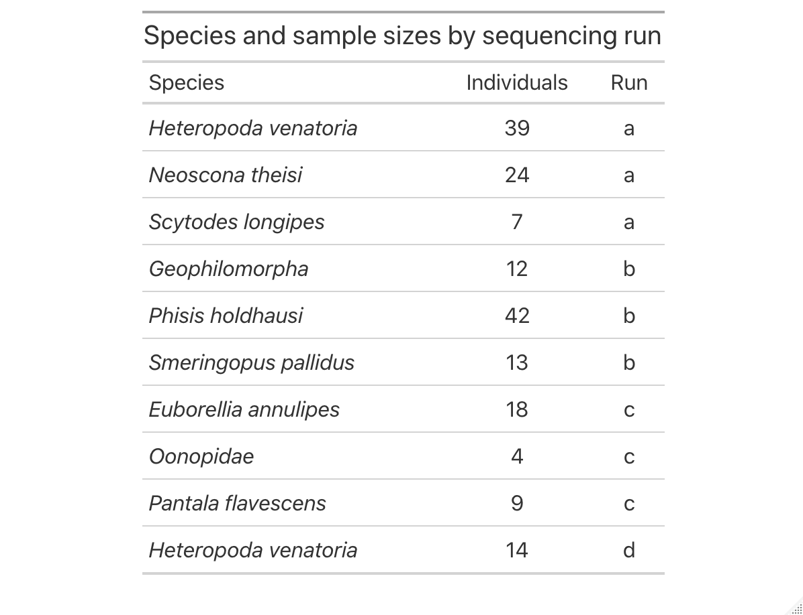

Table 2: Prey Class, Order, and Family taxonomies.

|  |  |  |
| --- | --- | --- |
| **Class** | **Order** | **Family** |
| Arachnida | Araneae | Araneidae |
| Arachnida | Araneae | Oxyopidae |
| Arachnida | Araneae | Pholcidae |
| Arachnida | Araneae | Salticidae |
| Arachnida | Araneae | Theridiidae |
| Arachnida | Sarcoptiformes | Acaridae |
| Arachnida | Sarcoptiformes | Pyroglyphidae |
| Arachnida | Sarcoptiformes | Suidasiidae |
| Chilopoda | Geophilomorpha | Mecistocephalidae |
| Collembola | Entomobryomorpha | Entomobryidae |
| Collembola | Entomobryomorpha | Isotomidae |
| Collembola | Symphypleona | Bourletiellidae |
| Collembola | Symphypleona | Sminthuridae |
| Insecta | Blattodea | Blaberidae |
| Insecta | Blattodea | Blattidae |
| Insecta | Blattodea | Ectobiidae |
| Insecta | Coleoptera | Coccinellidae |
| Insecta | Coleoptera | Curculionidae |
| Insecta | Coleoptera | Elateridae |
| Insecta | Coleoptera | Hydrophilidae |
| Insecta | Coleoptera | Staphylinidae |
| Insecta | Dermaptera | Anisolabididae |
| Insecta | Diptera | Agromyzidae |
| Insecta | Diptera | Calliphoridae |
| Insecta | Diptera | Cecidomyiidae |
| Insecta | Diptera | Ceratopogonidae |
| Insecta | Diptera | Chloropidae |
| Insecta | Diptera | Culicidae |
| Insecta | Diptera | Dolichopodidae |
| Insecta | Diptera | Limoniidae |
| Insecta | Diptera | Lonchaeidae |
| Insecta | Diptera | Phoridae |
| Insecta | Diptera | Platystomatidae |
| Insecta | Diptera | Psychodidae |
| Insecta | Diptera | Sciaridae |
| Insecta | Diptera | Stratiomyidae |
| Insecta | Hemiptera | Aleyrodidae |
| Insecta | Hemiptera | Coccidae |
| Insecta | Hemiptera | Pseudococcidae |
| Insecta | Hymenoptera | Eulophidae |
| Insecta | Hymenoptera | Evaniidae |
| Insecta | Hymenoptera | Formicidae |
| Insecta | Lepidoptera | Agonoxenidae |
| Insecta | Lepidoptera | Crambidae |
| Insecta | Lepidoptera | Erebidae |
| Insecta | Lepidoptera | Tineidae |
| Insecta | Odonata | Libellulidae |
| Insecta | Orthoptera | Acrididae |
| Insecta | Orthoptera | Mogoplistidae |
| Insecta | Orthoptera | Tettigoniidae |
| Insecta | Psocoptera | Ectopsocidae |
| Insecta | Psocoptera | Lepidopsocidae |
| Insecta | Psocoptera | Liposcelididae |
| Insecta | Psocoptera | Myopsocidae |
| Insecta | Thysanoptera | Thripidae |
| Malacostraca | Isopoda | Philosciidae |

Table 3: Samples and body sizes

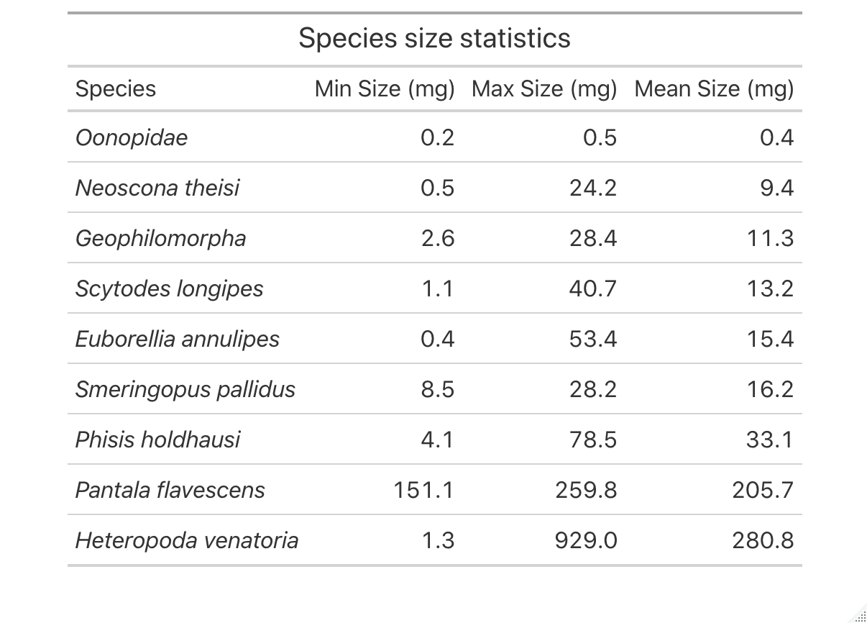

Figure 2: Sequencing depth of initial four samples rarefaction



We initially determined how many samples per sequencing run based on a MiSeq Nano run with four samples. From this, we determined that samples needed to be sequenced to a depth of roughly 140,000 reads to capture full OTU diversity. Thus, we based the number of samples per run (roughly 100) based on this optimal sequencing depth per sample.

Figure 3: Run-to-run variation in ASV number and diet family number

*Quantifying cross-run variation*

There was significant cross-run variation, with significant differences (pair-wise differences between runs with p-value ≤ 0.05) between run 1-4, 2-3, and 2-4. On average, samples had: A: 2.26 ± 0.15, B: 2.33 ± 0.24, C: 1.72 ± 0.23, and D: 1.44 ± 0.15 species in each sample. Because each species was run on a sequencing run with all other individuals from that species and because we did not compare species richness as a response variable across predator species in this study, we report this as the variation across sequencing runs but do not correct for it in future analyses.

Figure 4: Dada2 vs UNOISE3 – histogram



We compared the reads assigned using both the DADA2 and UNOISE3 algorithms. DADA2 produced more samples with high read abundances than UNOISE3 and so we used this denoising algorithm for this study.

Figure 5: DADA2 – cross-run errors



We ran DADA2 on samples across all four runs simultaneously and verified that error rates were similar (above figures) across all runs before doing so.

Figure 6: Sequencing depth across samples



Samples can be sequenced at wide ranges of sequencing depths (10,000 – 100,000 for the current study). We used these sequencing depths to determine which samples had been sequenced below a threshold after which the data from them was incomplete compared to samples that had been sequenced with greater depth.

Figure 7: Inflection point of quantiles of sequencing depth graph



Based on varying sequencing depths from above, we determined the quantiles of sequencing depths and removed all samples from analyses below the lowest quantile with the highest difference between it and the next quantile (at increments of 0.01). This was determined to be the 13th quantile and a sequencing depth below 11,211. All samples with sequencing depths below this threshold were removed from further analyses.

Figure 8: Mass-length relationships by species table and graph



We predicted the mass of predators in this study based on mass-length relationships from predators from Palmyra Atoll and the literature. Plotted are each species’ log10-log10 mass-length relationships, with the lines and black dots indicating predicted values for predator individuals in this study and the grey background dots the distributions of those predators used to build those models. This model had a significant by-species slope and R2m = 0.62 and R2c = 0.95.

Table 3: Model outputs for size model

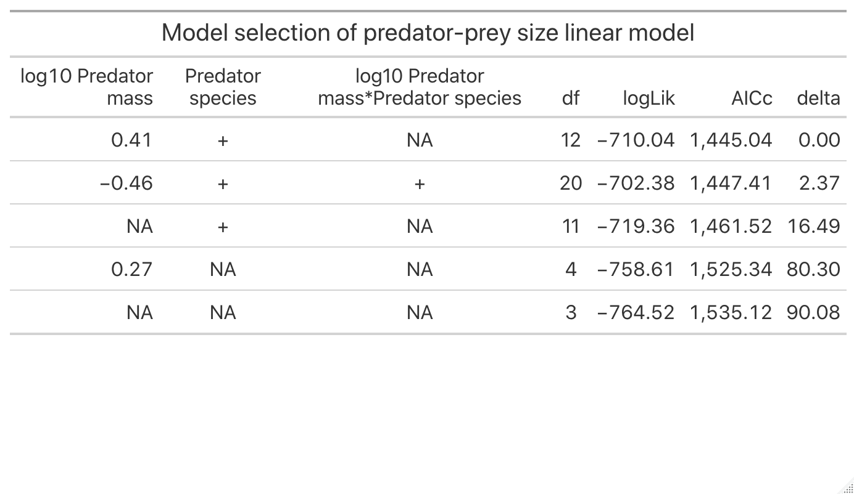

SI Figure: Size distribution for predators in CCA analysis

